BIRTHDAY POLYNOMIAL PROJECT

Objective: to create, characterize and graph a polynomial
function that reflects you!

Process:

- Write, IN ORDER, the digits of the month (1 or 2 digits), day (1 or 2 digits), and year (4 digits) of your birthday.

  - For example, February 27, 1986 would be “2271986”. You must use 6, 7, or 8 digits. If 0’s take up to many of your digits, replace them with your favorite number instead.

- Create a polynomial using your digits, in order.

  - For example:$f\left(x\right)=2x^{6}+2x^{5}-7x^{4}+x^{3}-9x^{2}-8x-6$.

- Experiment with the shape of your birthday polynomial by changing the signs (+/-) of various terms in desmos. Try to create a polynomial function with an interesting shape and some turning points. Be creative! You are trying to express yourself in this graph!

  - For example here is a picture of 2 different birthday polynomials with changed signs:
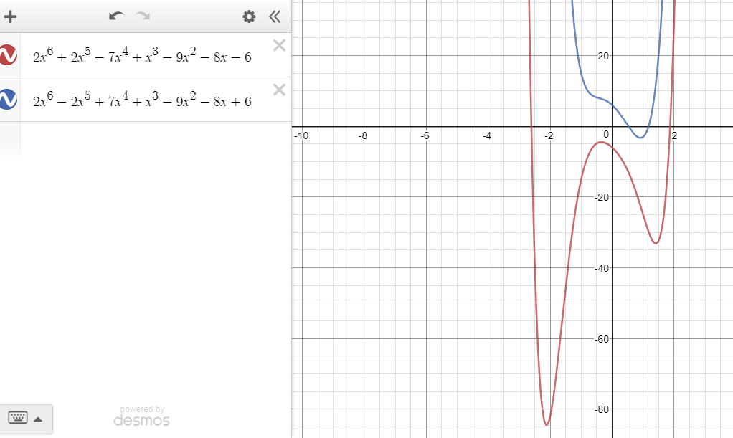
- Analyze your polynomial (using desmos, or just your super math skills)by finding these characteristics:

  - Domain and Range
  - The y-intercept
  - All real and complex zeros (include any multiplicities)
  - Minimums and maximums
  - End behavior

Product:
- Make a presentation of your polynomial. You could print this out and add color, or you could draw it yourself. I want it to be creative, colorful, neat and accurate.

At a minimum, your presentation should include a visual representation of the graph of your birthday polynomial, the equation itself, and written statements of your findings in part 4 above.

Assessment:
- Your grade will be weighted as a 12 Homework assignments, so 24 points. Your score will be based on three criteria:
  - The accuracy of your polynomial
  - The completeness and accuracy of your analysis
  - The accuracy, neatness, originality, and creativity of your presentation.
Rubric:

